

**Containers and**

**Docker Security**

***LAB FILE SUBMITTED BY: SUBMITTED TO:***

NAME: Palak Gupta Dr. Hitesh Kumar Sharma

SAP ID: 500109569

BATCH: 1 Devops

**EXPERIMENT 1**

**AIM: Installing Vagrant & Creating basic vagrant box using Virtual Box virtualization.**

**Steps to Complete:**

1. Download and Install Oracle Virtual Box 5.x and Vagrant 2.2.7.

2. Check working of Vagrant using vagrant --version command.

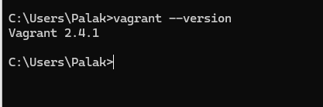

3. Create a new directory using CMD.

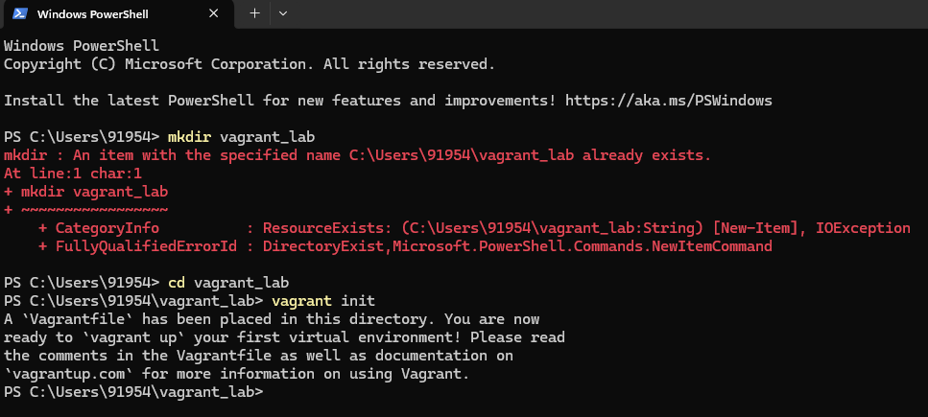

4. Run vagrant init command

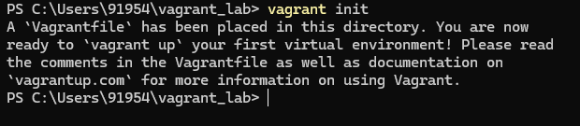

5. Edit vagrantfile and add ubuntu/xenial64 in box tag.

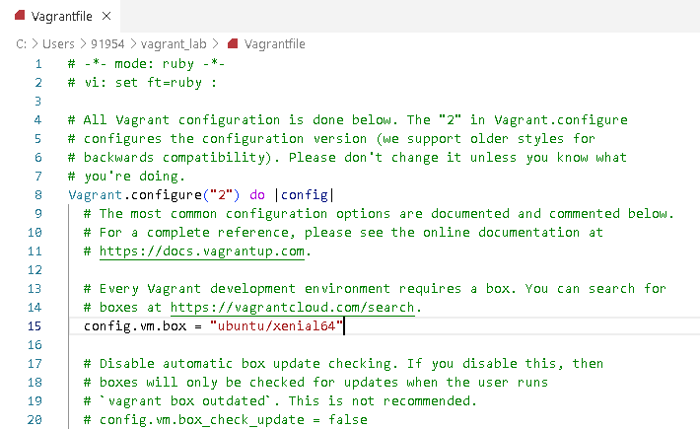

6. Run vagrant up command

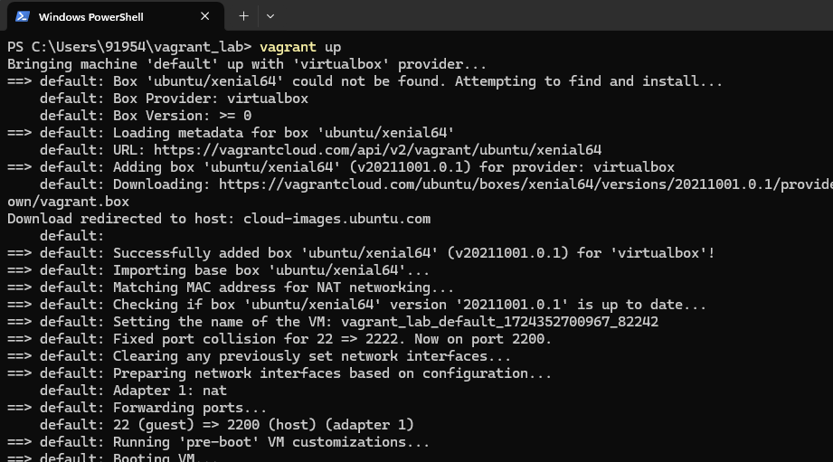

7. Run vagrant SSH command

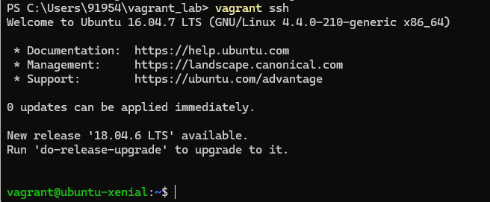

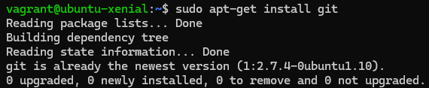

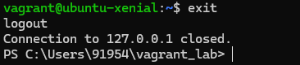

8. Run Vagrant Halt to stop VM

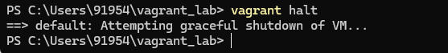

9. Run Vagrant Destroy to delete VM

